
Application Form

IMPORTANT NOTES FOR APPLICANTS

If you are selected for an interview you may bring whanau / support people at your own expense. Please advise in advance if this is your intention.

Shortlisted applicants will be asked to give consent to Police and MSD vetting and provide proof of qualifications and entitlement to work in New Zealand.

Odyssey House staff deal with experiences of people in relation to physical, emotional and sexual abuse and neglect. If you have had similar experiences in your life you may wish to discuss the impact of dealing with such situations with a personal support person or professional, prior to applying.

Odyssey Values
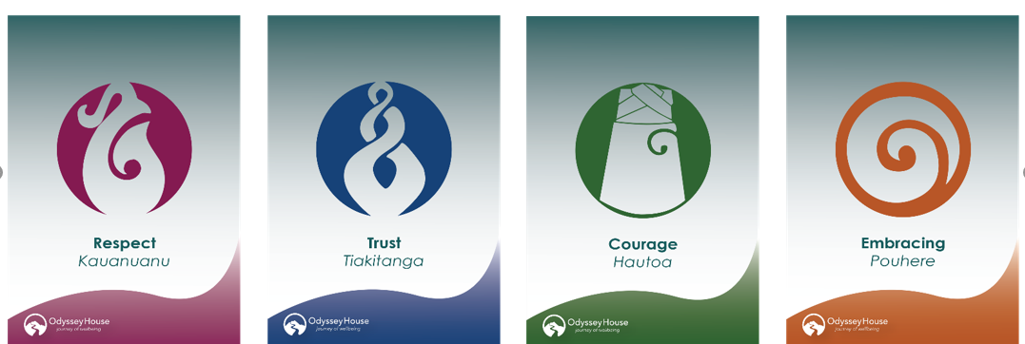

APPLICATION FOR EMPLOYMENT

Position Applied For:
Name (in full)
Mobile Phone |  |  | Other Phone
Email:
Have you been known by any name other than that stated above? | Yes | No |  | If ‘Yes’ please list
Do you have a current driver’s licence? | Yes | No |  | If ‘Yes’, Full, Restricted or Learners

Are you (please tick appropriate box)
New Zealand Citizen |  | New Zealand Resident |  | NZ Work Visa holder |  | Requiring sponsorship

Have you had any injury or medical condition which the tasks of this job may aggravate or contribute to? | Yes | No
Have you now, or at any time in the past, had any problems with addictions to alcohol or drugs? | Yes | No
Are there any other health factors that Odyssey House should know to assess your suitability for appointment and ability to do the job? | Yes | No
If you ticked any of the above, please detail here

Have you received or do you have charges pending on? (please tick) |  |  |  |  | Yes | No
Criminal Conviction |  | Police Diversion |  | Driving offence which resulted in temporary or permanent loss of licence  or imprisonment?
If you ticked any of the above, please detail here

Do you have a membership with an allied health registration body ie SWRB, NZAC, DAPAANZ | Yes | No | If ‘Yes’ please list
Have you ever been subject to any complaints or disciplinary action with an allied health registration body | Yes | No | If ‘Yes’, please detail

Odyssey House may wish to contact past employers and other persons as referees to obtain information about your background and suitability.
Do you authorise Odyssey House to contact third parties to obtain that information? |  |  | Yes |  |  | No
Please provide the names of three people who could act as referees for you.
Name | Organisation | Phone Number |  |  | Relationship to you

I certify that the information I have supplied in this application is true and correct. I understand that if I have supplied incorrect or misleading information, or have omitted any important information, I may be disqualified from appointment, or if appointed, may be dismissed.

Signature:
Date:

EQUAL EMPLOYMENT OPPORTUNITIES

The following information is to assist us in monitoring the success of our equal employment opportunities policy. Odyssey House Trust actively promotes equal employment opportunities.
Your cooperation in responding to the EEO section is invited on a voluntary basis.

Position applied for: | Location:

Are you: | Female |  | Male |  | Gender diverse

Please state yes (s) that most clearly describes you ( one or two boxes only ).
African |  | Niuean
Chinese |  | NZ European
Cook Island Maori |  | Southeast Asian
European |  | Tokelauan
Fijian |  | Tongan
Indian |  | Other Asian
Latin American / Hispanic |  | Other Pacific Island
Maori |  | Pacific Islander
Middle Eastern |  | Samoan
Please state other ethnic origin |  | I do not want to provide this information

